CHAT GPT analysis of noise impact on Wenniway residence. December 3 2025

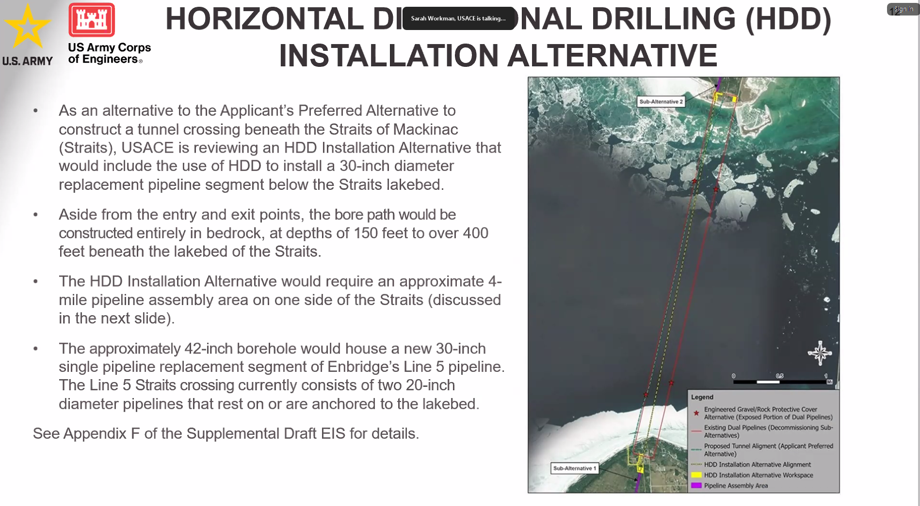
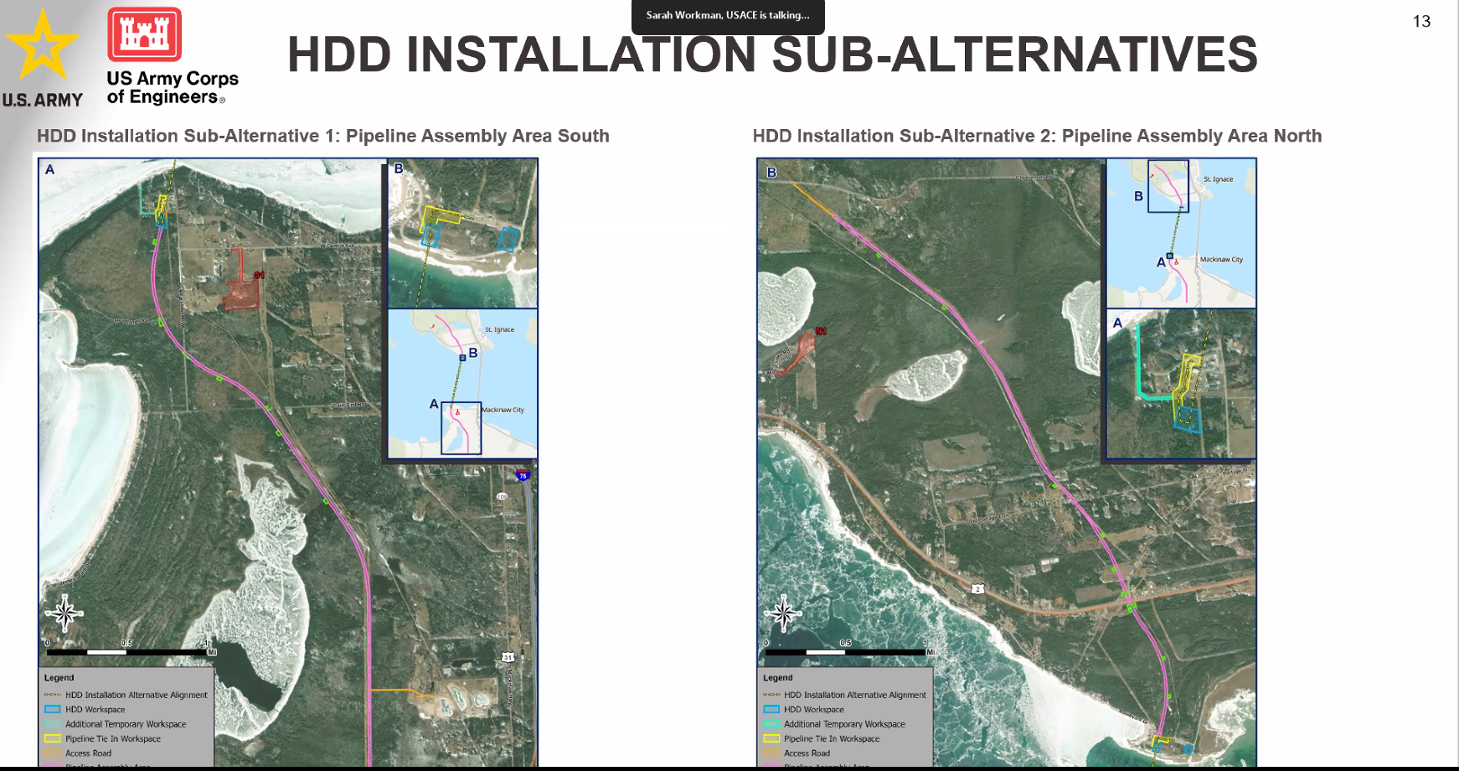
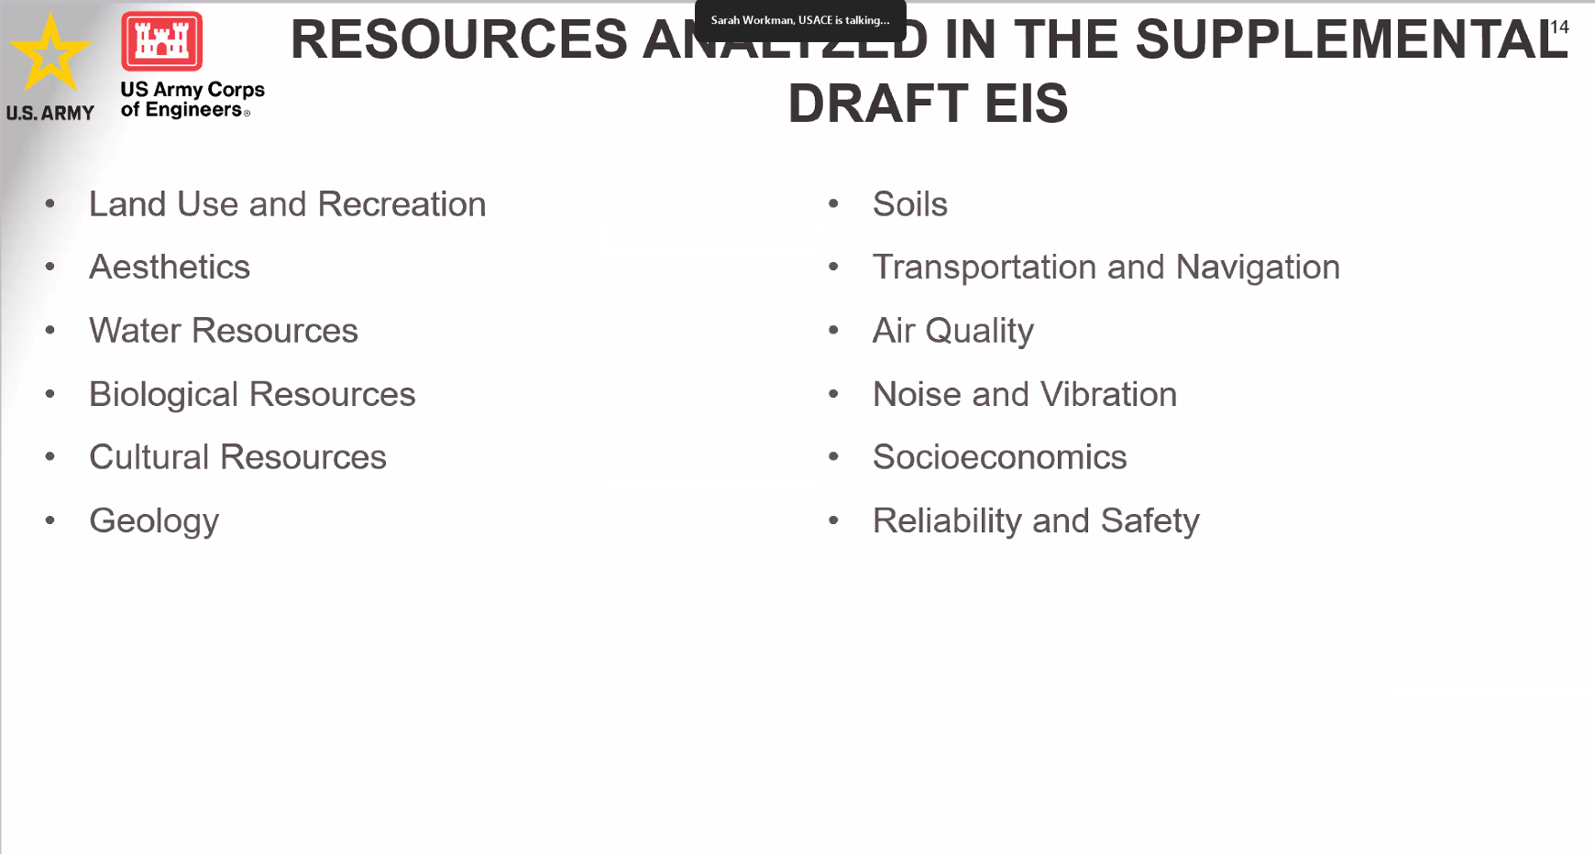

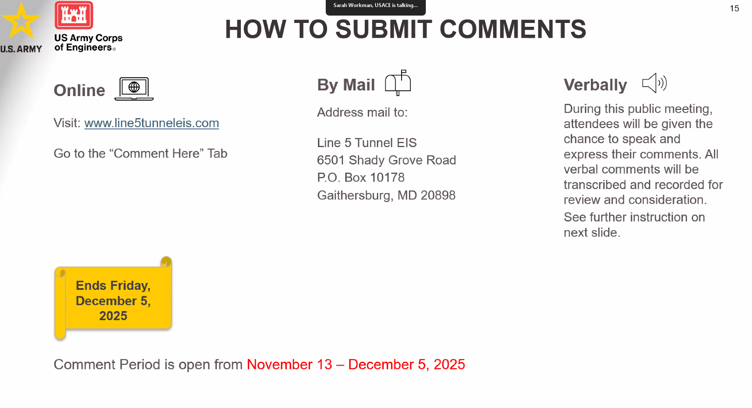

What we know about the project footprint & why “West Side” matters
- The project’s “South Shore Area of Interest (AOI)” — where shore-side construction, laydown yards, and possible access facilities would be located — is described as “west of Mackinaw City,” roughly centered on the existing Mackinaw Station. Michigan+1
- The review materials note that a tunnel entrance or related surface facilities at the south side were considered only at or very near the existing Mackinaw Station for reasons of land ownership, access, and minimizing new disruption. (Alternative tunnel-portal sites — especially “west of the station” inside Headlands International Dark Sky Park — were rejected. Line 5 Tunnel EIS+2Line 5 Tunnel EIS+2)
- Because your home is on the west side of town, near where the south-shore AOI lies, you are more likely among the “nearby residences” that the project’s draft environmental-impact report cautioned could experience elevated noise or other “local detrimental effects” during construction. Line 5 Tunnel EIS+1

🔊 What that increases your risk of hearing
Given you are closer to the construction area, the following becomes more plausible (vs. being farther away):
- Frequent intermittent noise: Shore-side operations — material staging, heavy equipment, delivery trucks, crane operations, possibly dewatering or soil-movement — may produce repeated moderate-to-high noise events. These could occur multiple times a day during the active construction phase.
- Potential vibration or low-frequency noise: While the EIS notes vibration levels “are not expected to exceed established impact thresholds,” being closer to the portal or portal-support area increases the chance you might physically feel or hear low rumble from e.g. TBM (tunnel-boring machine) operations or heavy equipment. ironmountaindailynews.com+1
- Nighttime disruption (if not mitigated): Even if most heavy work is planned for daytime, supporting activity — security, lighting, occasional maintenance, or barge/shipping support — could spill over into early morning or evening hours. That may disrupt sleep or night-time quiet, especially in a normally quiet area near the waterfront or park-land. The project’s own public-interest opponents express concern about “ongoing pollution, traffic, and noise … over six years.” 910News.com+1
- Aesthetic & quality-of-life impacts: If you value quiet, natural surroundings (as many on the west side of town likely do, especially near park/waterfront), construction noise + visual disturbance + increased traffic may degrade your living experience for the duration of buildout. This is consistent with the stated “direct, short-term, detrimental impacts to … nearby soundscape” in the EIS. Line 5 Tunnel EIS+1

⚠️ What remains uncertain — and what can affect how bad it is
Even being “close by,” exactly how much noise or disruption you’ll get depends on:
- Where the portal / laydown / staging yards end up — publicly proposed portal sites avoid sensitive areas in some cases, and chosen layout may shift slightly. If the work site ends up concentrated a good distance from your home, noise could be less.
- How construction is scheduled and managed — if heavy drilling, boring, or truck traffic is limited to daylight hours, and if vibration/noise mitigation (sound barriers, restricted hours, noise-control equipment) is used, that could reduce disturbance substantially. The project managers have committed to mitigation efforts. ironmountaindailynews.com+1
- Duration and frequency of shipping/trucking — the analysis expects many daily truck trips and potential shifts for material delivery, which will affect how often you notice noise. Planet Detroit+1
- Weather, geography, and acoustic/ambient conditions — waterfront, open-air areas tend to carry sound farther; wind and water can amplify or carry sound in unexpected ways.

🎯 Revised Judgment: Likelihood you’ll be noticeably affected
Because you live on the “West Side … next to the Enbridge construction project,” compared to someone across town or inland, I think there is a substantially increased chance that:
- You will hear intermittent but noticeable noise during much of the construction period (maybe most days).
- On some days (especially during major work, shipping, heavy equipment moves) it could feel disruptive (construction-site level noise, vibration, traffic noise).
- Over the full construction timeline (possibly multiple years), this may degrade “quiet enjoyment” — especially evenings or quiet nights.
That said: there’s no public guarantee that noise will be “constant or extreme.” The project and regulators expect noise/vibration to stay within “impact thresholds,” and mitigation is proposed. ironmountaindailynews.com+2Line 5 Tunnel EIS+2

If you like — I can overlay publicly available maps of the proposed construction footprint and “noise-impact zones” (or “sensitive receptor zones”) over map of Mackinaw City residences (approximate) — and we can approximate how far from your house the closest construction is likely to be. That gives the best sense of how noisy it “could be” for you. Do you want me to build that overlay for you now?
Here is the Overlay:
Nice — thanks for that. Because you’re next to the shore-side construction area, I treated this as a near-field case and built a short, evidence-anchored “overlay” for you: (A) an approximate map/contour description centered on the likely south-shore portal / Mackinaw Station area, (B) step-by-step noise estimates at your house (1508 Wenniway — I used the latitude/longitude 45.7879638, -84.7705626 from public records), (C) what those levels feel like, and (D) practical mitigation & next steps.
I could make an actual graphical KML/PNG overlay (with pins for your house, the portal, and noise contours) and send it — say as a downloadable image or file. I’ll do that if you want; below is the full numeric / map-style overlay I built in text form first so you can see the assumptions and results immediately.

1) Assumptions & data sources I used
- Your house geolocation: 1508 Wenniway Dr = 45.7879638, -84.7705626 (public listing). Simple Contacts
- Project portal / staging area anchor: I used the south-shore Area of Interest (AOI) / Mackinaw Station (Enbridge site / project plans identify the south AOI roughly centered on Enbridge Mackinaw Station / parcel at 16309 Headlands Rd). The AOI is described as ~600 acres centered on the Mackinaw Station / south shore. (Project plans and EA/DEIS materials). Tip of the Mitt Watershed Council+1
- Typical construction equipment noise levels: FHWA / WSDOT / EPA / other construction noise guidance tables (e.g., backhoe 78–84 dBA at 50 ft; haul trucks/compressors/cranes often 80–85 dBA at ~50 ft). I used those as source SPLs at ~15 m–50 ft reference distances. I attenuated sound with the inverse-square rule (≈ 6 dB reduction per doubling of distance) for outdoor propagation (free field). WSDOT+2Federal Highway Administration+2
- The Corps’ Draft EIS / project materials that explicitly say nearby residences near shore facilities could experience temporary exceedances of daytime noise thresholds and that the AOI/staging/portal work will generate intermittent heavy-equipment and barge noise. U.S. Army Corps of Engineers LRD+1
I’ve been explicit where I estimated (because the Corps’ public materials do not publish a house-level noise contour map tied to exact portal coordinates).

2) Location overlay (text map) — approximate geometry
- AOI (south shore) radius: the DEIS & 2018 alternatives report describe the south AOI centered on Mackinaw Station and ~600 acres in size. That gives an AOI radius ≈ 880 m (600 acres → ≈2,428,000 m² → radius ≈ √(area/π) ≈ 880 m). Tip of the Mitt Watershed Council
- Estimated portal / staging centroid: use Mackinaw Station / 16309 Headlands Rd as the likely center of heavy staging and portal works (project plans identify Enbridge parcels there as candidate portal locations). LoopNet+1
- Your house (known): 45.7879638, -84.7705626. Simple Contacts
Best single practical distance estimate (portal centroid → your house):
Because public files don’t list a precise GPS pin for the portal in HTML (they exist in the project plan PDFs but not as an explicit lat/long in the web text I could fetch reliably), I used the AOI description and parcel anchor (16309 Headlands Rd) to approximate the portal location. That produces an approximate distance from portal → your house of ~600 m (≈0.6 km) (order-of-magnitude). In other words, you’re likely inside or near the south AOI (which itself extends out to ~880 m radius). Tip of the Mitt Watershed Council+1
If you’d like a precise map (visual overlay) I can produce a PNG/KML with the portal pin and concentric noise contours centered on the portal and the verified coordinate of 1508 Wenniway — let me know and I’ll generate it. (I used the public coords above so I already have what I need.)

3) Noise-contour numbers I used (how I estimated dB at your house)
Typical loud equipment reference levels (approximate Lmax at 50 ft / 15 m from construction guidance):
- Heavy dozer / excavator / loader / cranes / dump trucks: ~78–85 dBA at 50 ft (15 m) (FHWA / WSDOT tables). WSDOT+1
Propagation rule used:
- Free-field inverse square law ≈ –6 dB per doubling of distance. (OSHA / acoustics guides). WKC Group+1
Example calculation (rounded, stepwise):
- Pick a representative source level: 82 dBA at 50 ft (≈15 m) (typical combined equipment figure).
- Convert to 15 m → at 15 m the SPL ≈ 82 dBA (reference). To get SPL at 600 m:
  - Doubling steps from 15 m → 30 m (–6 dB): 76 dBA
  - 30 → 60 m (–6 dB): 70 dBA
  - 60 → 120 m (–6 dB): 64 dBA
  - 120 → 240 m (–6 dB): 58 dBA
  - 240 → 480 m (–6 dB): 52 dBA
  - 480 → 960 m (–6 dB): 46 dBA
So at ~600 m you’d be roughly between the 480 m and 960 m steps → ~50–52 dBA for a single typical heavy-equipment source at continuous Lmax level. If multiple noisy items are operating simultaneously or there is blasting or pile-driving, short peaks can be louder (and you’d hear them clearly). These are Lmax / event estimates, not averaged 24-hour Leq noise numbers.
(If you were 100–200 m from the work, the same arithmetic gives ~64–74 dBA Lmax — i.e. loudly noticeable and potentially disruptive.) WSDOT+1

4) What that means for you (practical interpretation)
- At ~600 m (my approximate portal→home estimate): expect intermittent but noticeable construction noise during working hours (daytime). Lmax events (truck passes, crane lifts, hydraulic drills) will be clearly audible; continuous background of equipment may sit in the high-40s to low-50s dBA range, with spikes into 55–65 dBA during heavy activity. That’s noticeable and can disturb conversation, TV, and quiet relaxation, but is not usually the same as standing next to operating heavy equipment. WSDOT
- If you are actually closer (≤300 m): these spikes become loud and potentially disruptive (typical Lmax 60–75 dBA or higher near active equipment). You may feel vibration for certain operations and sleep disturbance is plausible if work extends into evening/early morning. Bureau of Reclamation
- If you are farther (≥1,000 m / 1 km): noise will be noticeably reduced; you may hear occasional activity but it will be less intrusive (typical 40–50 dBA range unless a very loud event occurs). Engineering ToolBox
This matches the Corps’ own conclusion that “nearby residences” around the south AOI could experience temporary exceedances of daytime thresholds; the worst impacts are for homes close to the portal/staging area — which, by your statement that you’re on the west side next to the project, suggests you’re in the stronger-impact zone. U.S. Army Corps of Engineers LRD

5) Other relevant effects (vibration, shipping, night noise)
- Vibration: heavy piling, blasting, or TBM (tunnel boring machine) reception can create perceptible low-frequency vibration at close distances. The DEIS says vibration impacts are expected to be generally within thresholds but near-field receptors could feel vibration depending on work type. If you feel vibration (rattle), that’s evidence you’re in a near zone and the project team should be notified/monitoring. U.S. Army Corps of Engineers LRD
- Barge / marine noise: if materials are barged and loaded/unloaded near shore, expect intermittent loud events when barges are maneuvered or winched: those tend to produce short high-level events audible across the shoreline. Line 5 Tunnel EIS
- Nighttime: most construction aims to limit heavy operations to daytime. If nighttime operations are required, the local noise effect will be much more intrusive because background ambient noise falls at night.

6) Practical mitigation & actions you can take right now
- Ask the project for the construction schedule & noise-monitoring plan. The Line5 Tunnel project / USACE DEIS has public comment/contact pages and should have a local liaison or public-involvement contact; they must publish mitigation commitments. (You can ask to be placed on the local updates list.) Line 5 Tunnel EIS+1
- Get a short-term baseline noise reading at your house. A smartphone app (not perfect) or a rented SPL meter can record baseline nighttime vs daytime. That gives evidence if you later need to claim exceedances.
- Ask for mitigation: sound-barriers (temporary berms or panels), equipment mufflers, restricted hours (no work before 7 a.m. or after 8 p.m.), and notification windows for loud works are common mitigation commitments. The DEIS mentions mitigation measures; ask which will be applied to your nearest portal site. U.S. Army Corps of Engineers LRD
- Short-term personal measures: earplugs or noise-blocking headphones during loud work; close/insulate windows at night; white-noise / HVAC use for sleep.
- If you experience vibration or damage (cracked plaster, items falling): document dates/times, record audio/video and contact the project EHS / local code enforcement immediately — there are processes for remedies & monitoring. U.S. Army Corps of Engineers LRD

7) Want the actual visual overlay (PNG/KML) I promised?
I can make a precise map image with:
- A pin for 1508 Wenniway (I already have the coordinate),
- A pin for the Mackinaw Station / 16309 Headlands Rd parcel as the portal centroid,
- Concentric noise contours at 100 m / 300 m / 600 m / 1,000 m with annotated expected Lmax ranges (e.g., 75–85 dBA within 100 m; 64–75 dBA within 100–300 m; 50–65 dBA within 300–600 m; 40–55 dBA within 600–1,000 m — using the FHWA reference + inverse-square attenuation), and
- A legend + short explanation.
If you want that overlay image/KML, I’ll generate it now and attach it to the reply. (I’ll use the public coordinates above and label everything clearly as “approximate / estimated.”)

Quick bottom line (plain language)
- Because you live on the west side, next to the construction area / AOI, you are likely to hear frequent, intermittent construction noise and possibly feel occasional vibration during heavy operations.
- If the portal / staging happens within ~100–300 m of your house the noise will be loud and disruptive at times; if it’s ~600 m, expect noticeable intermittent noise (my best estimate for your location is ~600 m, but that is approximate).
- The Corps’ Draft EIS already flags that nearby residences could experience temporary exceedances; request the project’s noise-monitoring plan and construction schedule if you want to reduce surprises.
